Comparison between calculated and measured knee contact forces
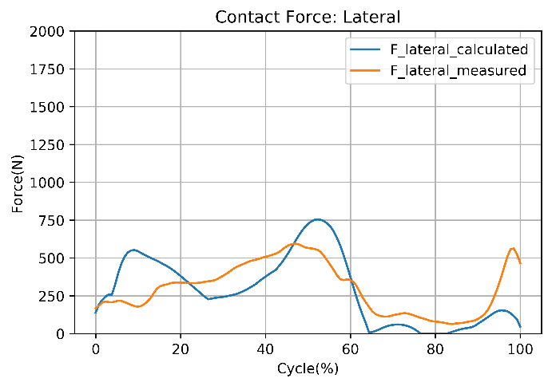 | 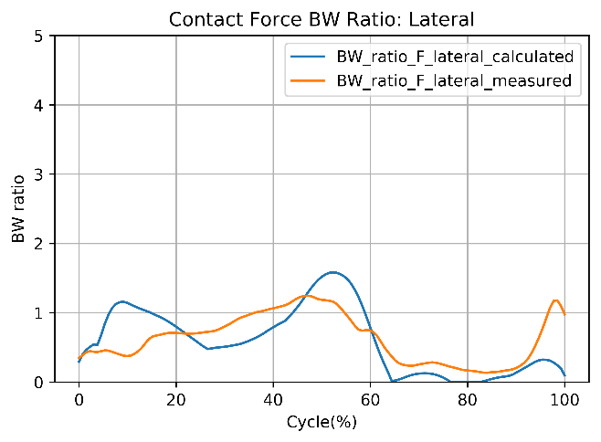
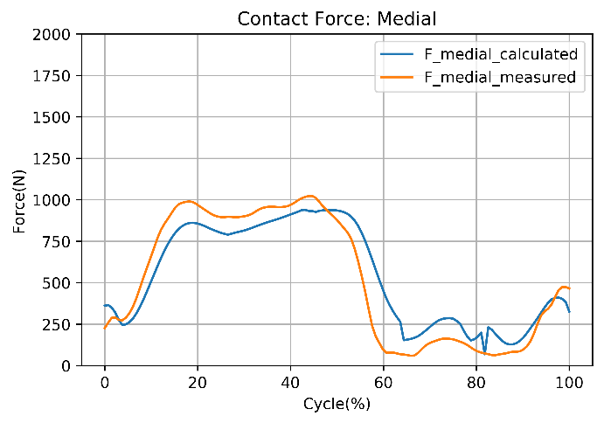 | 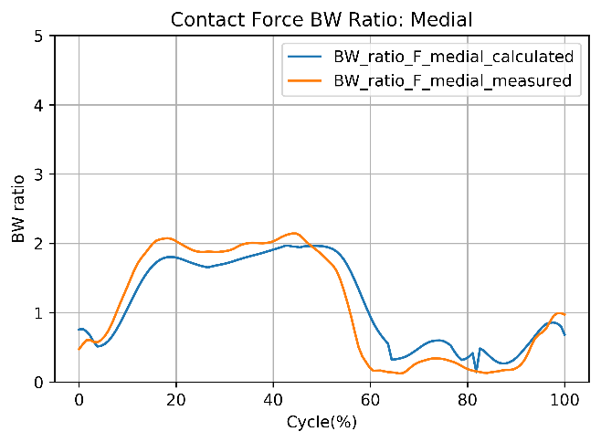
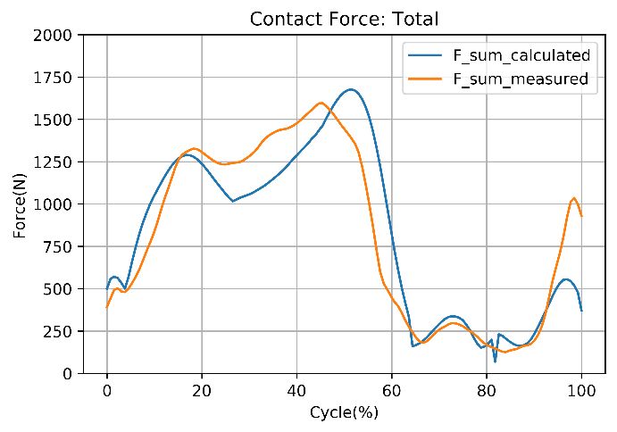 | 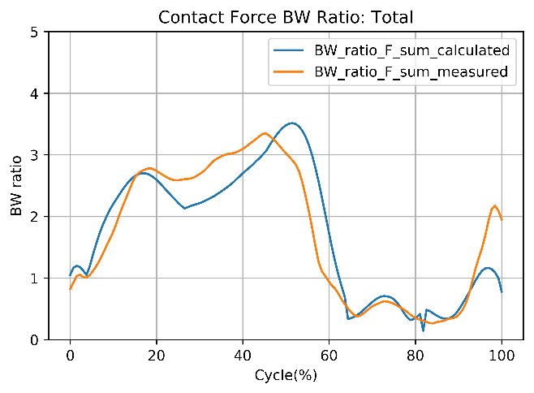

Agreement between calculated and measured knee contact forces
Forces | RMSE (BW unit) | $r^{2}$(squared Pearson correlation coefficient, p<0.001)
Gait – Lateral | 0.351 | 0.672
Gait – Medial | 0.282 | 0.945
Gait – Total | 0.456 | 0.906

